Stacked Composite Solids

Definition
# Source: AI Source: Provided by: [Data Path: Persons Table -> ID Column: 1, Name_En Column: Motasem Essam] -> From: [ChatGPT] on [7/25/2026]
Stacked Composite Solids are three-dimensional geometric structures formed by placing two or more solid components above one another in successive vertical or inclined levels.
The components are arranged in layers, with each component positioned on top of another or supported by components in a lower level. They may consist of identical solids or different geometric shapes, such as cubes, rectangular prisms, cylinders, cones, pyramids, spheres, and hemispheres.
Stacked composite solids can have uniform, stepped, symmetrical, asymmetrical, or irregular arrangements.

Simple Definition
# Source: AI Source: Provided by: [Data Path: Persons Table -> ID Column: 1, Name_En Column: Motasem Essam] -> From: [ChatGPT] on [7/25/2026]
A stacked composite solid is a three-dimensional structure formed by placing multiple geometric solids on top of one another.

Geometric Representation
# Source: AI Source: Provided by: [Data Path: Persons Table -> ID Column: 1, Name_En Column: Motasem Essam] -> From: [ChatGPT] on [7/25/2026]
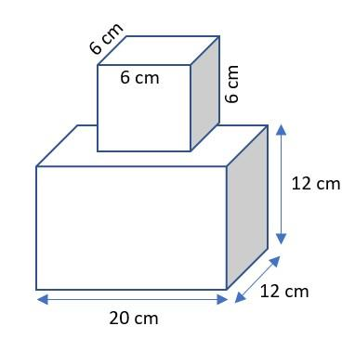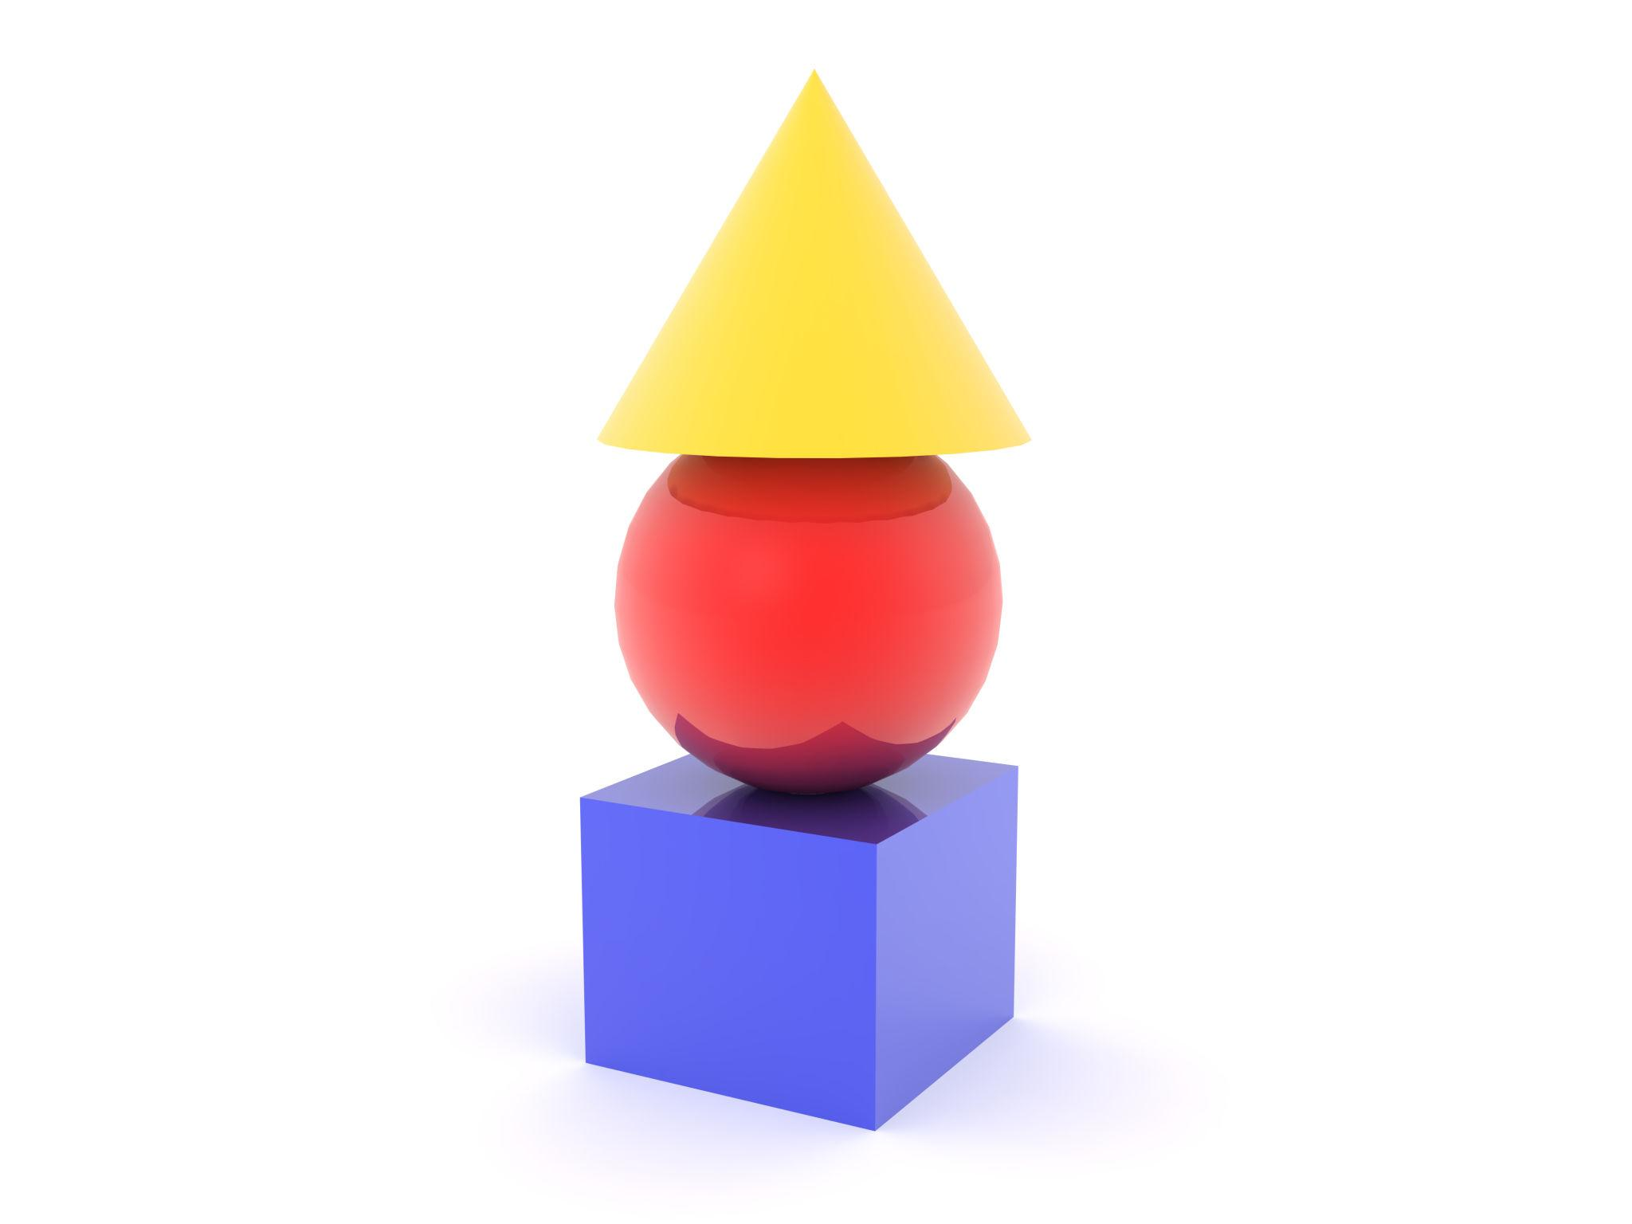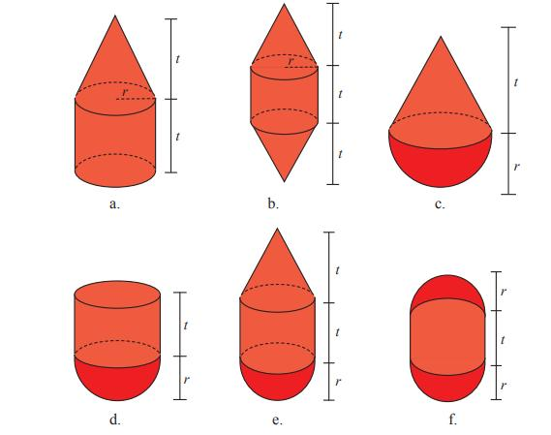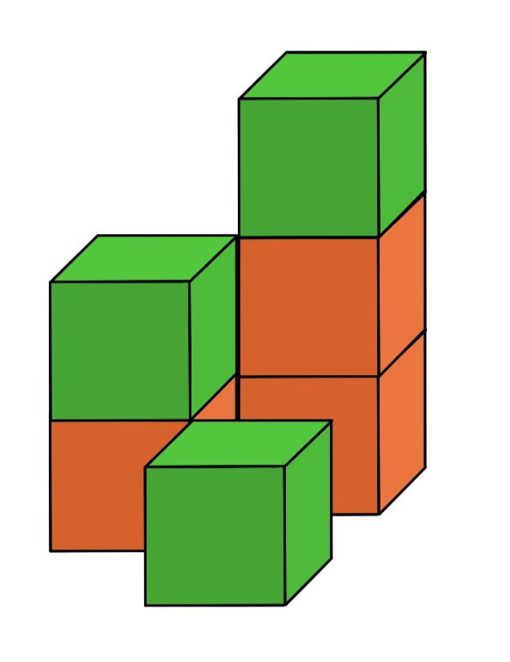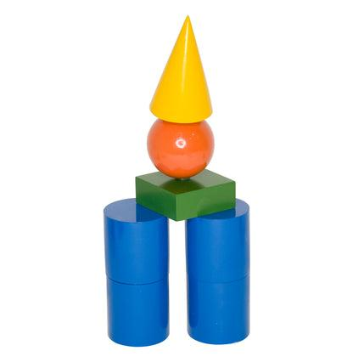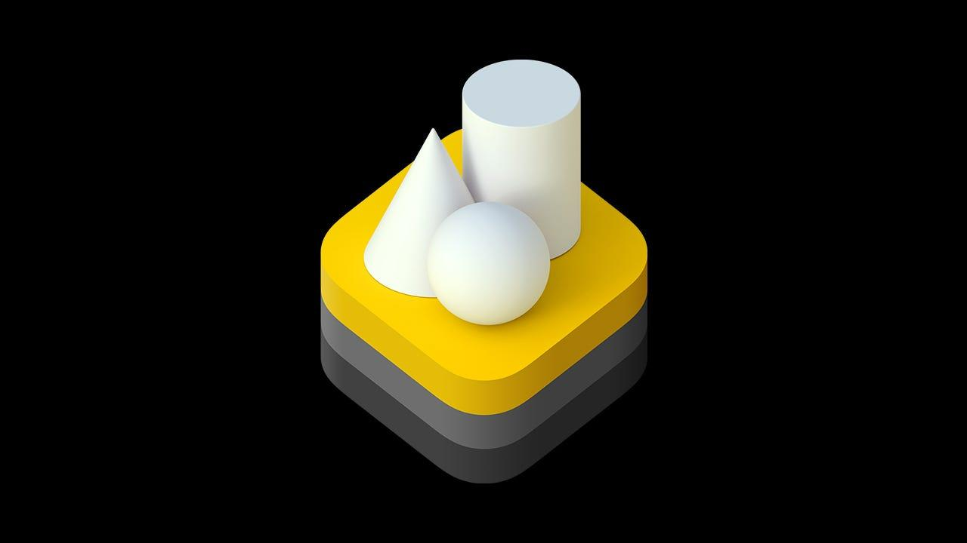
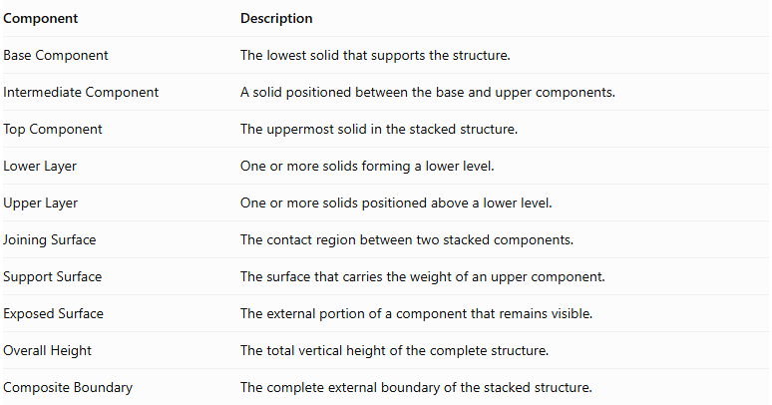
Component | Description
Base Component | The lowest solid that supports the structure.
Intermediate Component | A solid positioned between the base and upper components.
Top Component | The uppermost solid in the stacked structure.
Lower Layer | One or more solids forming a lower level.
Upper Layer | One or more solids positioned above a lower level.
Joining Surface | The contact region between two stacked components.
Support Surface | The surface that carries the weight of an upper component.
Exposed Surface | The external portion of a component that remains visible.
Overall Height | The total vertical height of the complete structure.
Composite Boundary | The complete external boundary of the stacked structure.

Types of Stacked Composite Solids

Vertically Stacked Composite Solids
# Source: AI Source: Provided by: [Data Path: Persons Table -> ID Column: 1, Name_En Column: Motasem Essam] -> From: [ChatGPT] on [7/25/2026]
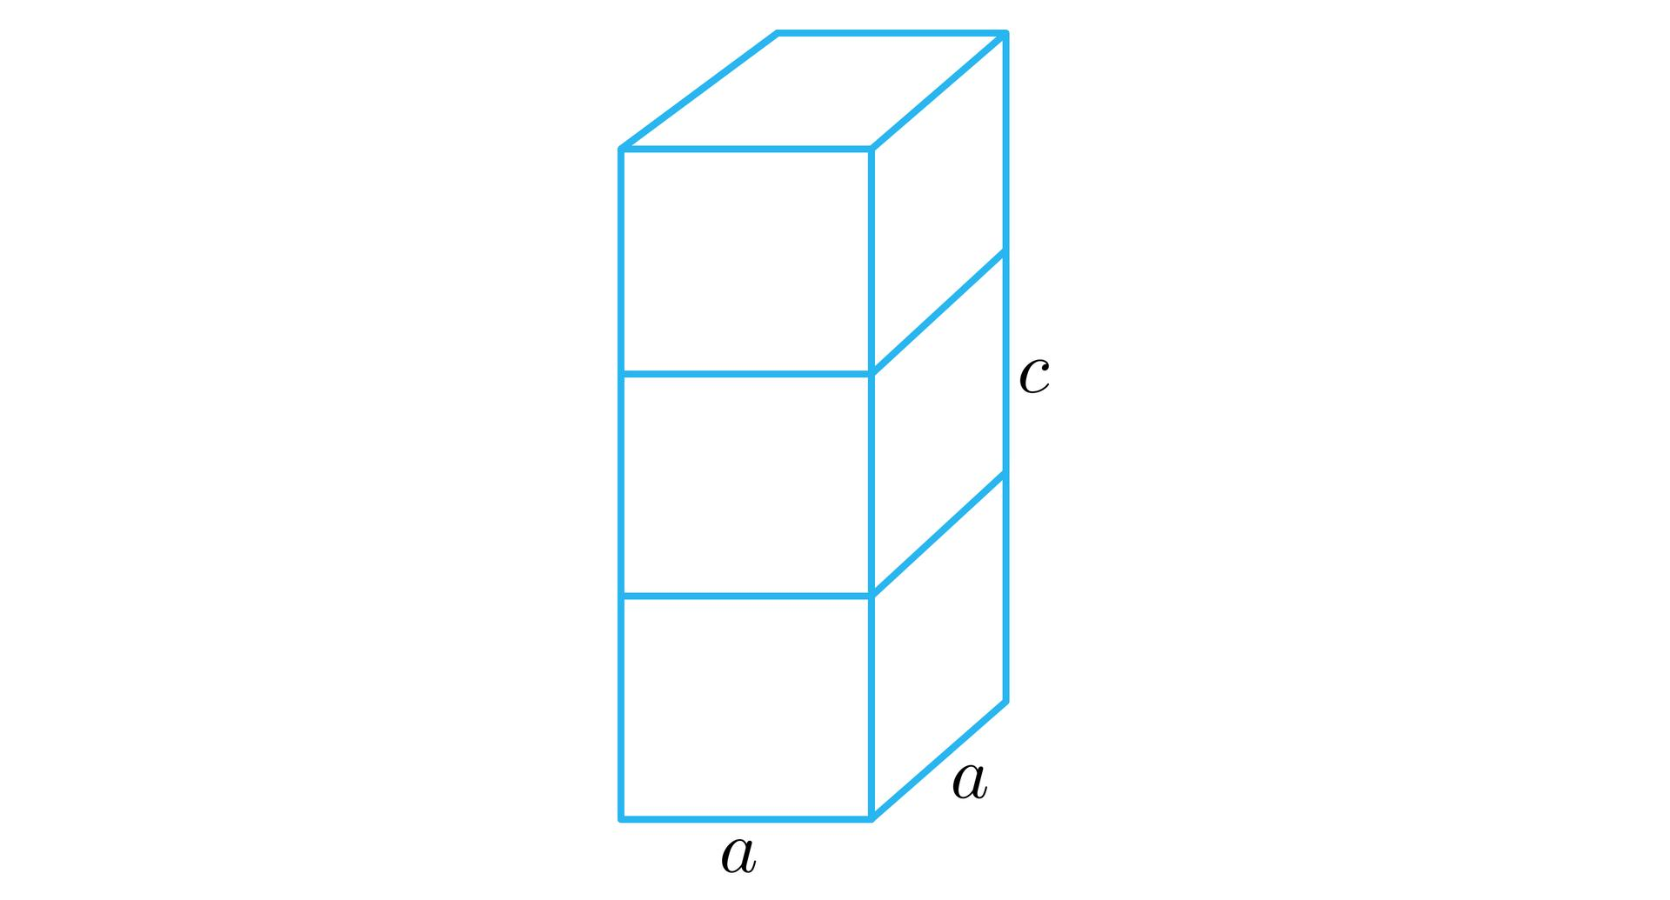
Solids arranged directly above one another along a vertical direction.
- Components are positioned in successive vertical levels.
- Their central axes may be aligned.
- They may have equal or different dimensions.
- They can form towers or column-like structures.

Horizontally Layered Composite Solids
# Source: AI Source: Provided by: [Data Path: Persons Table -> ID Column: 1, Name_En Column: Motasem Essam] -> From: [ChatGPT] on [7/25/2026]
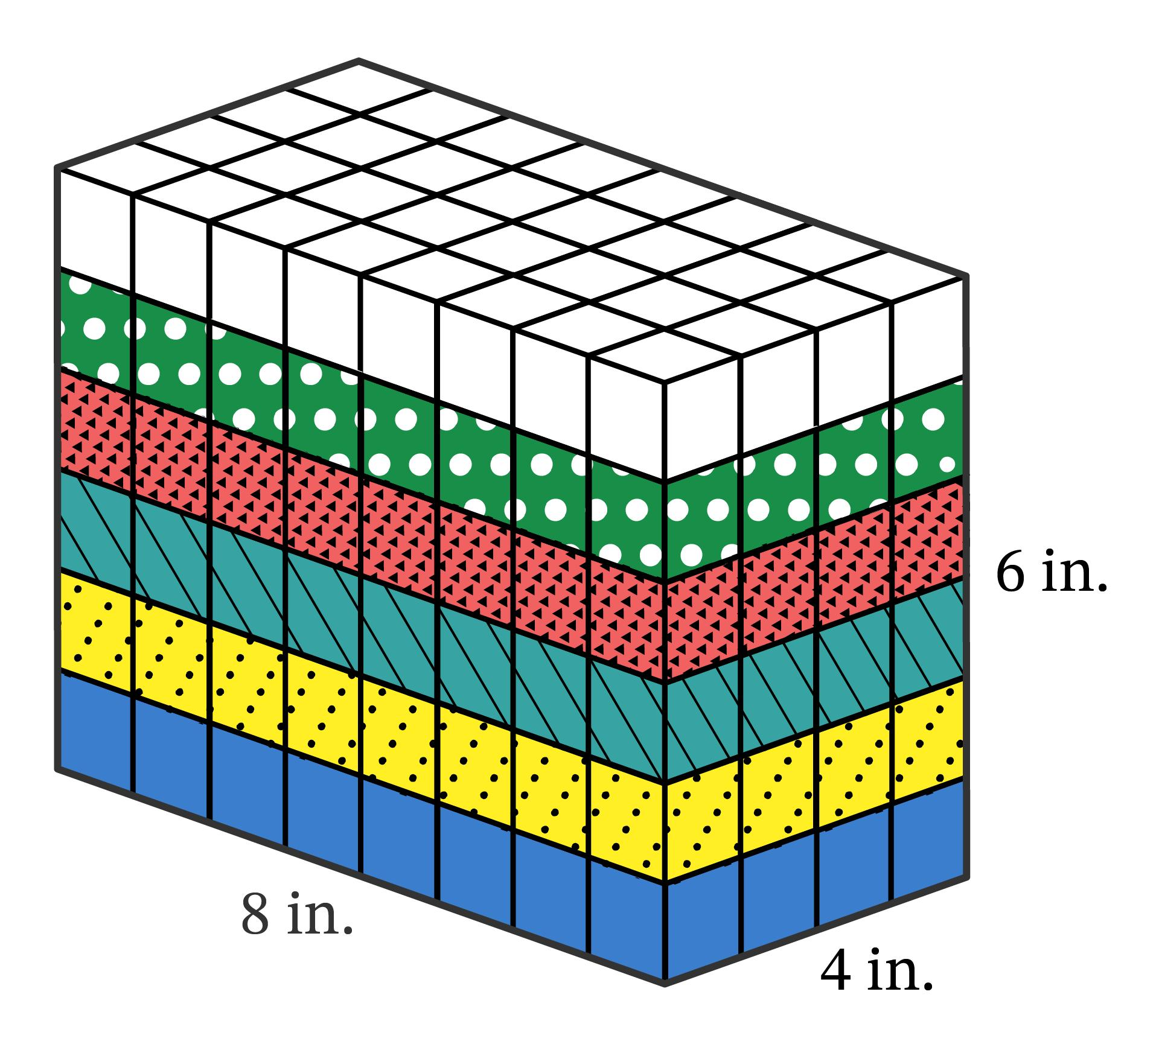
Solids organized into horizontal layers, with one layer positioned above another.
- Each layer may contain one or multiple components.
- Different layers may have different dimensions.
- The structure may have a uniform or stepped outline.

Uniform Stacked Composite Solids
# Source: AI Source: Provided by: [Data Path: Persons Table -> ID Column: 1, Name_En Column: Motasem Essam] -> From: [ChatGPT] on [7/25/2026]
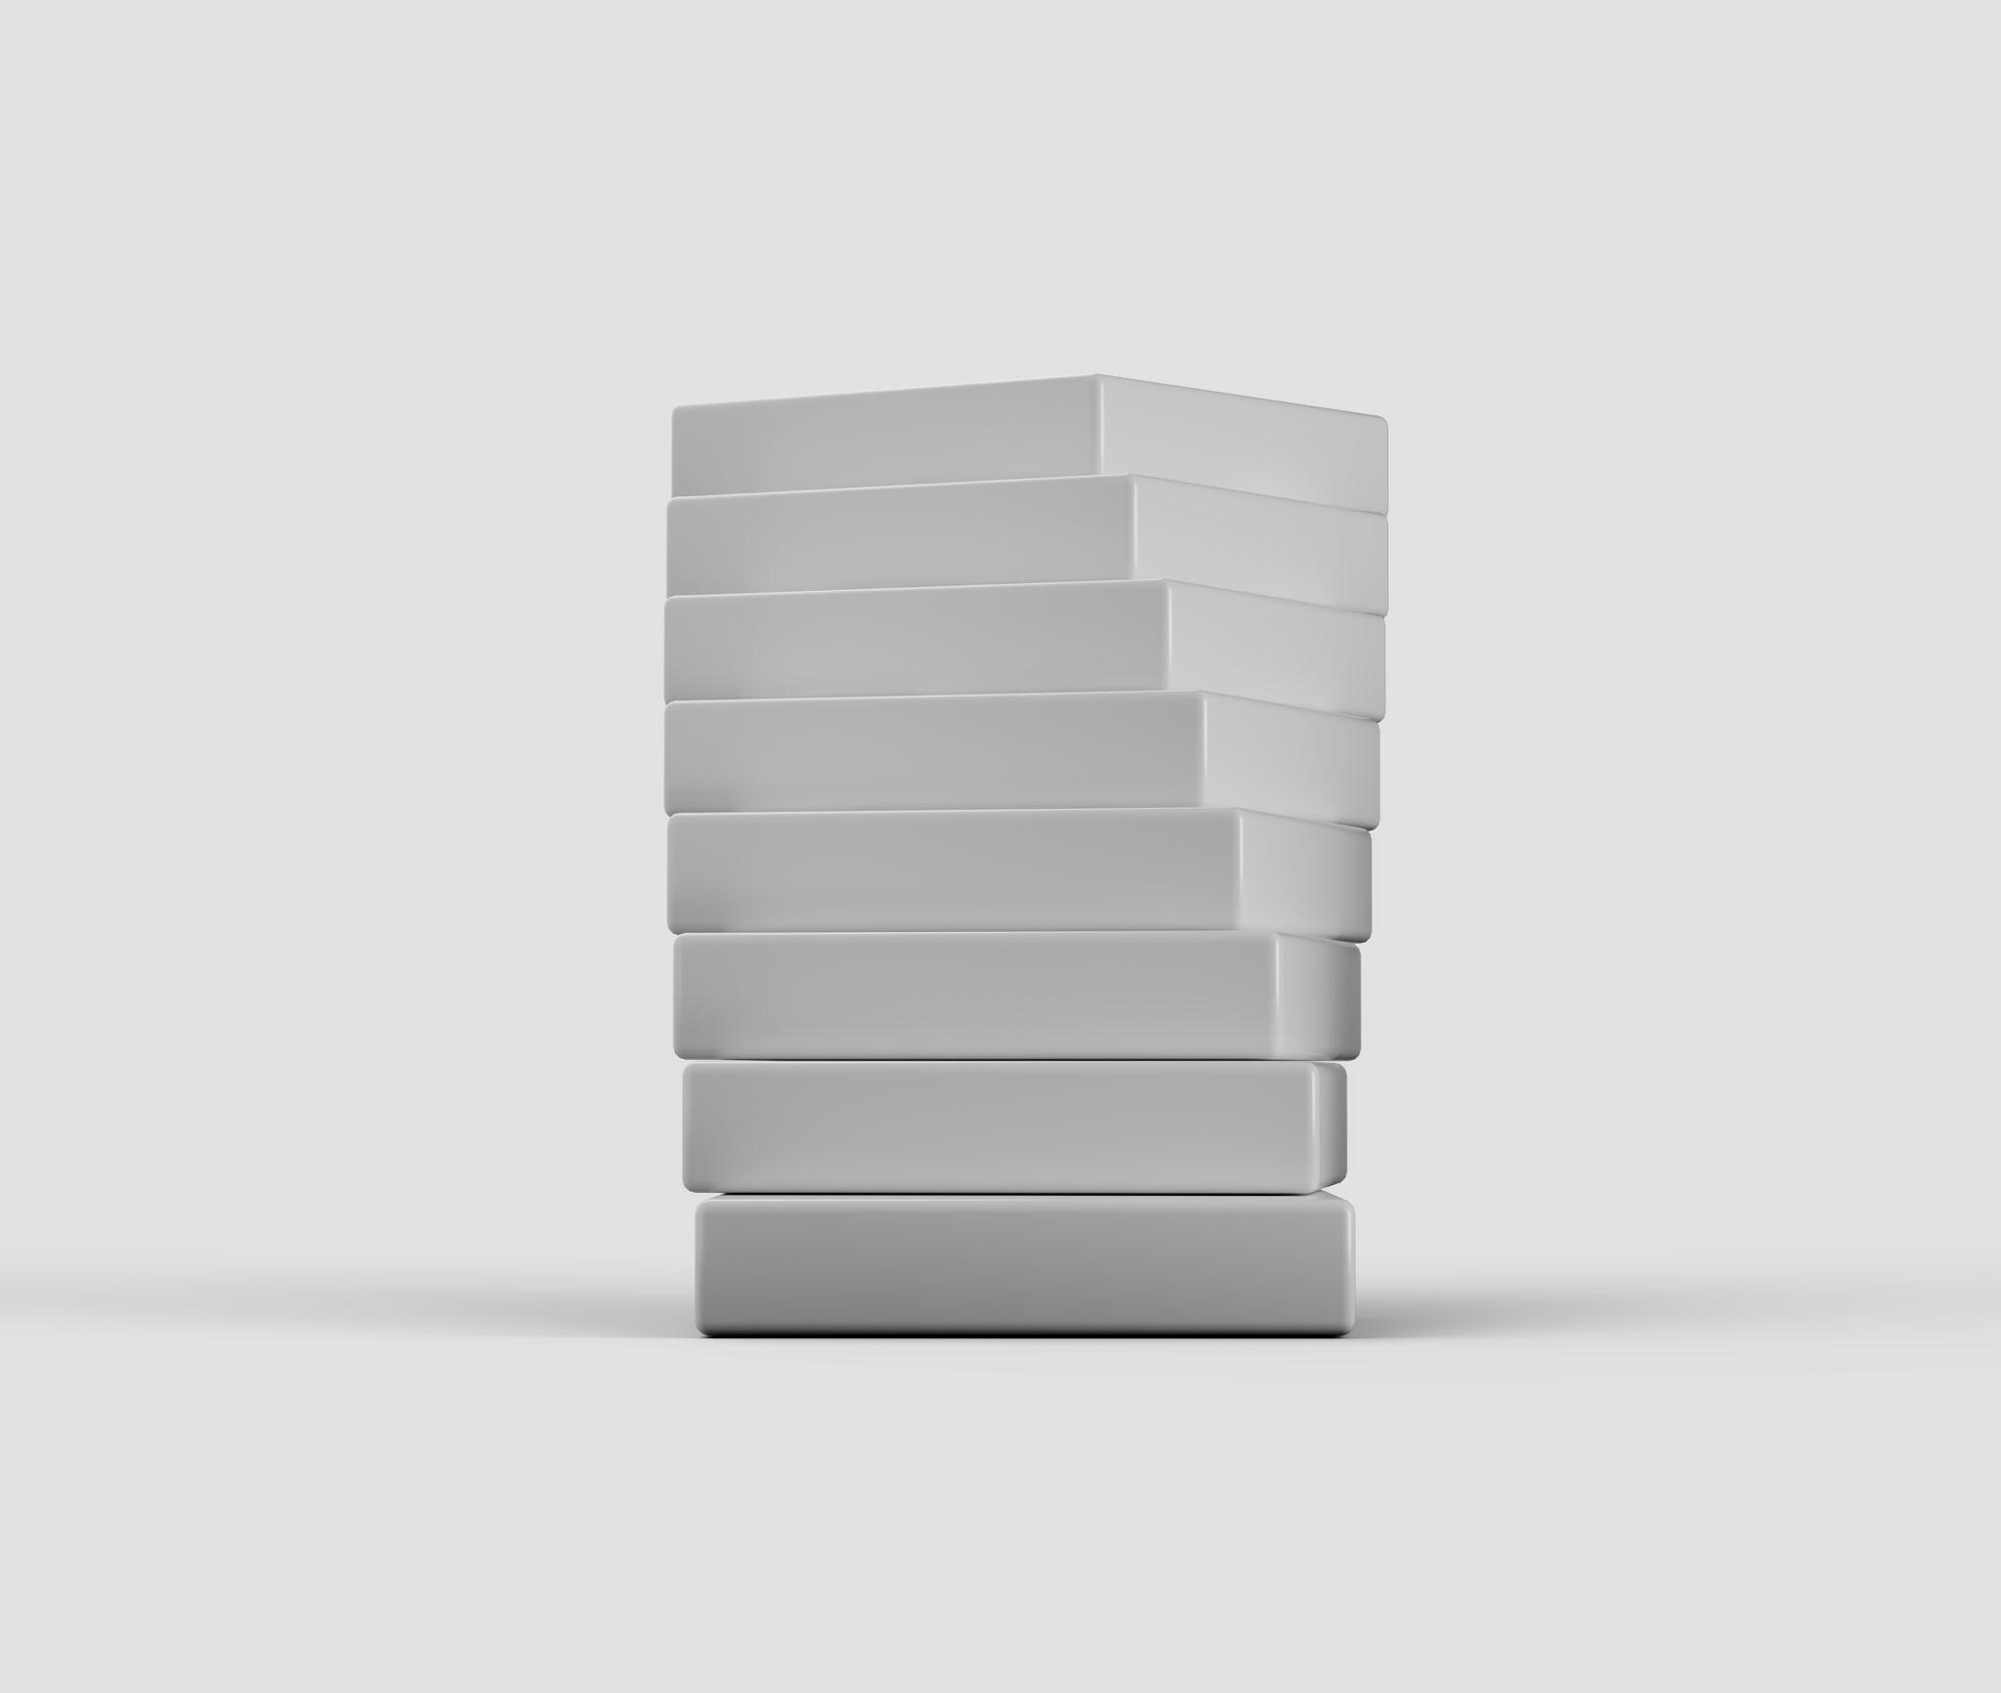
Structures formed by stacking components with consistent dimensions and repeated arrangements.
- Each component may have identical dimensions.
- Layer heights may be equal.
- The arrangement follows a consistent pattern.

Non-Uniform Stacked Composite Solids
# Source: AI Source: Provided by: [Data Path: Persons Table -> ID Column: 1, Name_En Column: Motasem Essam] -> From: [ChatGPT] on [7/25/2026]

Structures formed by stacking components with different dimensions.
- Components may vary in width, depth, and height.
- Upper layers may be smaller or larger than lower layers.
- The resulting structure may have an irregular external boundary.

Stepped Stacked Composite Solids
# Source: AI Source: Provided by: [Data Path: Persons Table -> ID Column: 1, Name_En Column: Motasem Essam] -> From: [ChatGPT] on [7/25/2026]
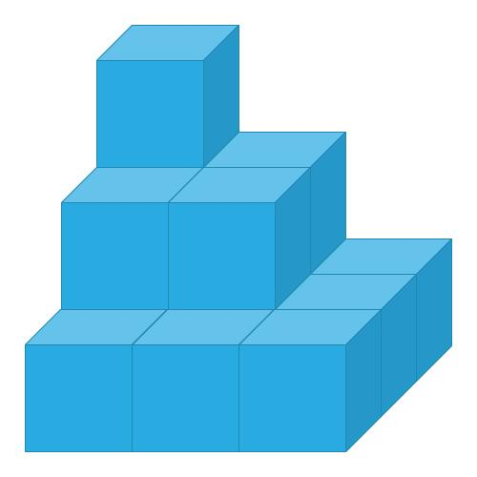
Structures in which successive layers are positioned with different horizontal offsets or dimensions, producing a staircase-like profile.
- Each level may be shorter or narrower than the level below.
- Components may be aligned on one side or centered.
- The arrangement creates one or more stepped surfaces.

Pyramid-Like Stacked Composite Solids
# Source: AI Source: Provided by: [Data Path: Persons Table -> ID Column: 1, Name_En Column: Motasem Essam] -> From: [ChatGPT] on [7/25/2026]

Structures formed by arranging progressively smaller components toward the top.
- Lower layers generally contain more components.
- Upper layers contain fewer components.
- The overall shape resembles a pyramid, although the components may be cubes, prisms, or other solids.

Symmetrical Stacked Composite Solids
# Source: AI Source: Provided by: [Data Path: Persons Table -> ID Column: 1, Name_En Column: Motasem Essam] -> From: [ChatGPT] on [7/25/2026]
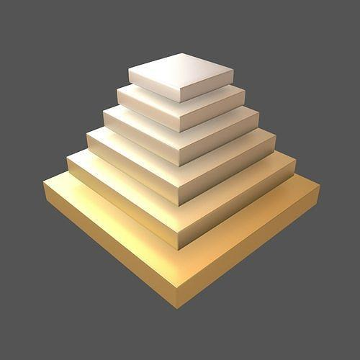
Structures in which components are arranged symmetrically around a central vertical axis or plane.
- Upper and lower layers may be centered.
- Corresponding components may have equal dimensions.
- The structure may possess reflectional or rotational symmetry.

Asymmetrical Stacked Composite Solids
# Source: AI Source: Provided by: [Data Path: Persons Table -> ID Column: 1, Name_En Column: Motasem Essam] -> From: [ChatGPT] on [7/25/2026]
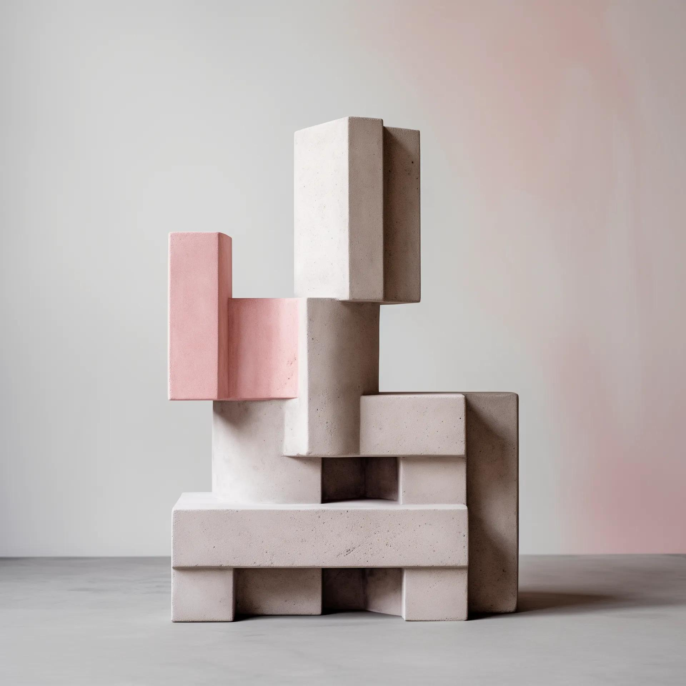
Structures in which components are stacked without maintaining symmetry.
- Layers may be offset in different directions.
- Components may have varying dimensions.
- The structure may have an uneven or unbalanced appearance.

Mixed-Shape Stacked Composite Solids
# Source: AI Source: Provided by: [Data Path: Persons Table -> ID Column: 1, Name_En Column: Motasem Essam] -> From: [ChatGPT] on [7/25/2026]
Structures formed by stacking different types of geometric solids.
- A cylinder may be placed on a rectangular prism.
- A cone may be placed on a cylinder.
- A pyramid may be placed on a cube.
- Multiple solid types may appear in successive layers.

Multi-Component Layered Stacked Composite Solids
# Source: AI Source: Provided by: [Data Path: Persons Table -> ID Column: 1, Name_En Column: Motasem Essam] -> From: [ChatGPT] on [7/25/2026]
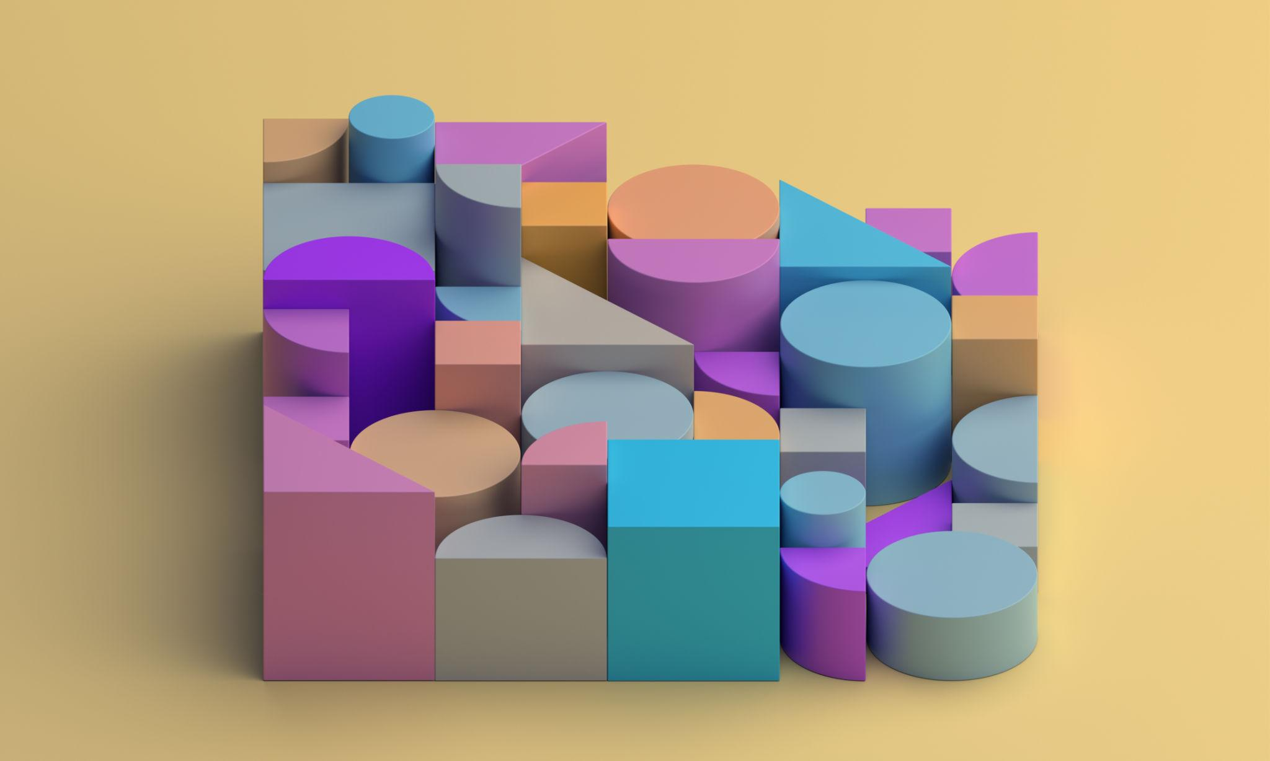
Structures in which each layer contains multiple components.
- A layer may contain several solids arranged side by side.
- Different layers may contain different solid types.
- The overall structure can be regular or irregular.

Radially Stacked Composite Solids
# Source: AI Source: Provided by: [Data Path: Persons Table -> ID Column: 1, Name_En Column: Motasem Essam] -> From: [ChatGPT] on [7/25/2026]
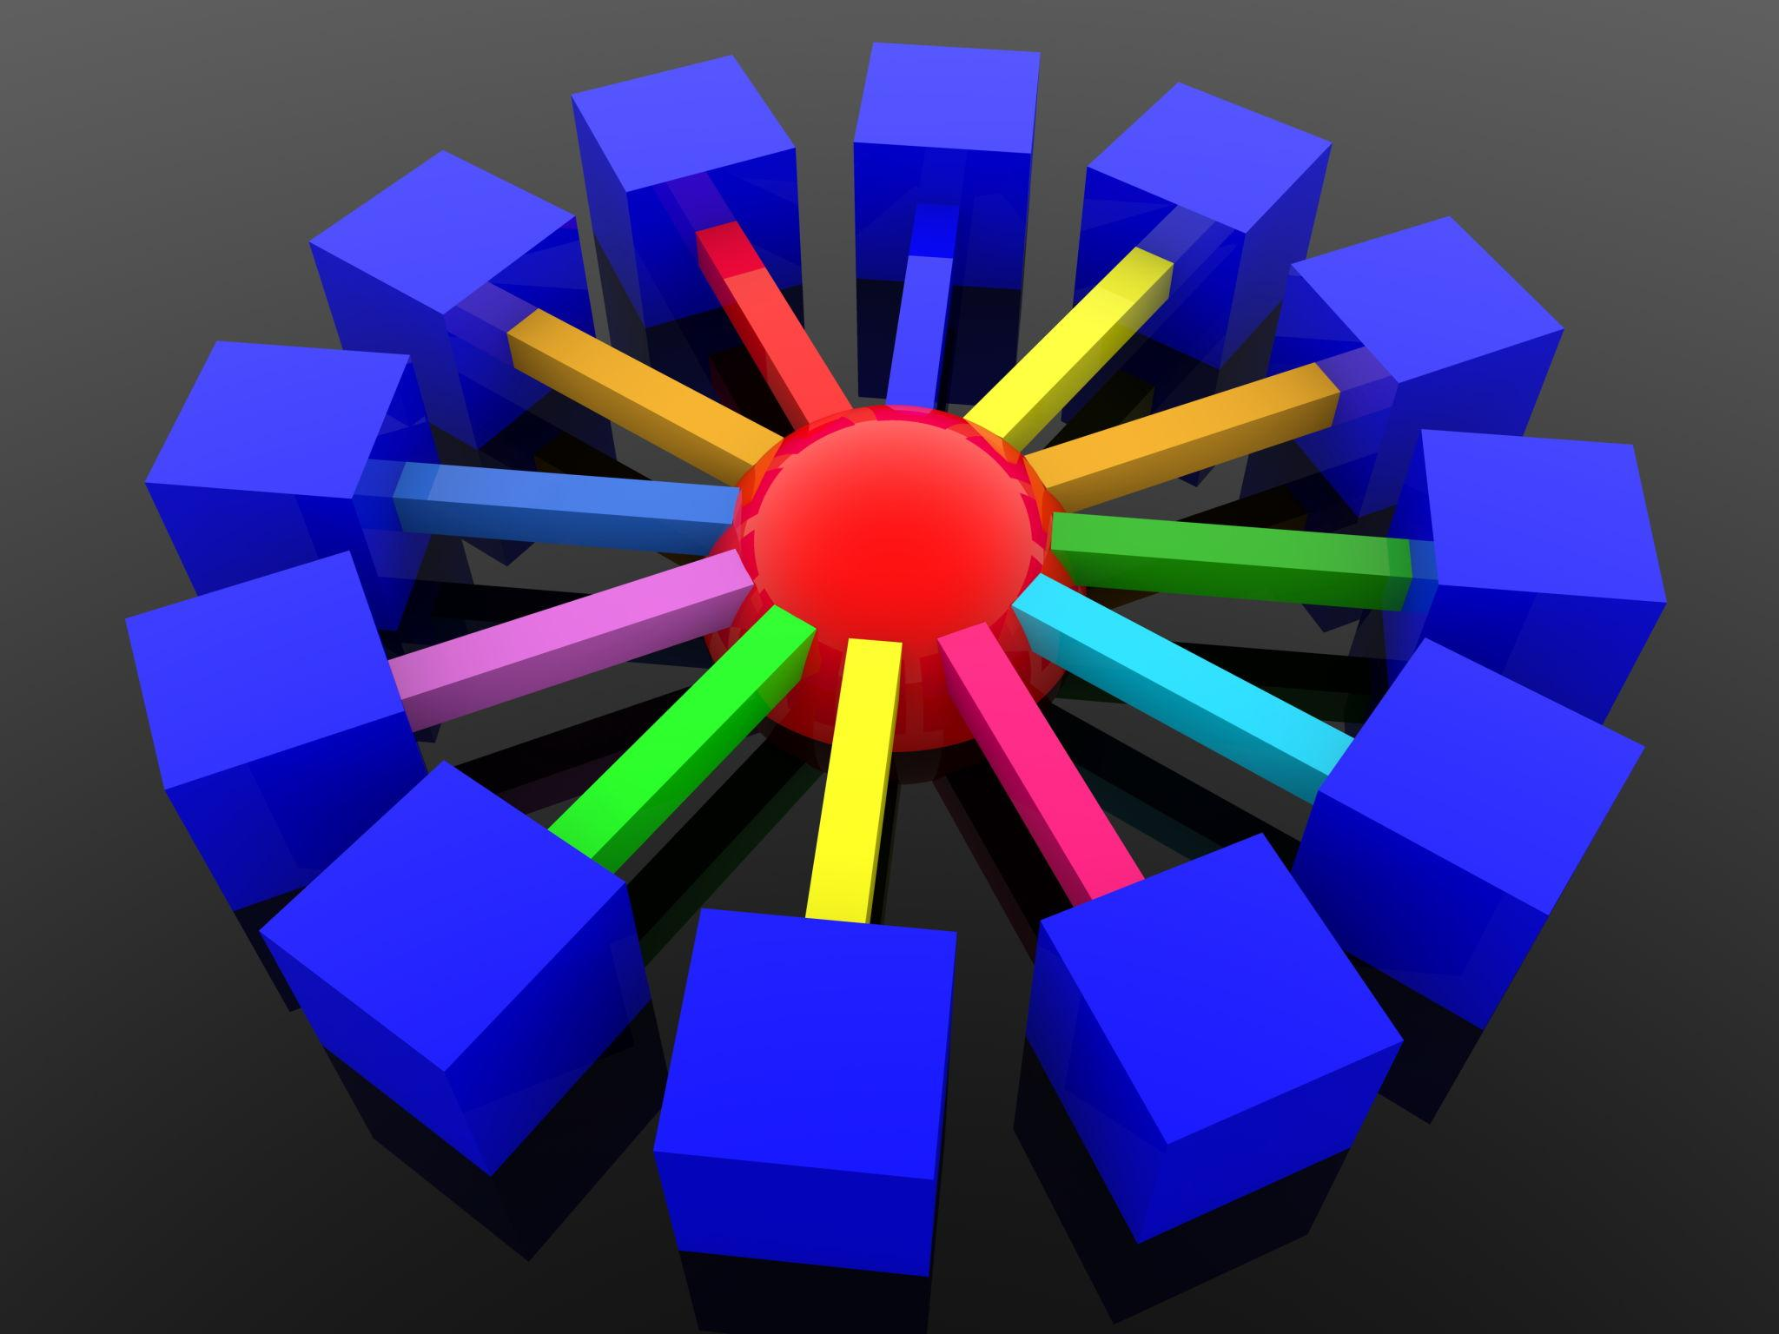
Structures in which components are arranged around a central vertical axis at different levels.
- Each layer may contain components distributed around a center.
- The arrangement may have rotational symmetry.
- The structure may form a circular or polygonal pattern.

Nested Stacked Composite Solids
# Source: AI Source: Provided by: [Data Path: Persons Table -> ID Column: 1, Name_En Column: Motasem Essam] -> From: [ChatGPT] on [7/25/2026]
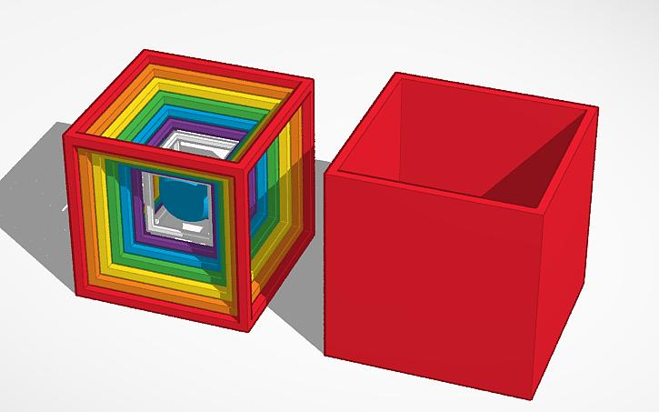
Structures in which components are positioned within cavities or spaces of other components while also forming successive levels.
- Components may be partially or fully enclosed.
- The structure may contain hollow regions.
- Volume and surface-area calculations depend on the internal geometry.

Classification by Number of Layers

Single-Layer Composite Solids
# Source: AI Source: Provided by: [Data Path: Persons Table -> ID Column: 1, Name_En Column: Motasem Essam] -> From: [ChatGPT] on [7/25/2026]
A structure consisting of one level containing multiple components.

Two-Layer Composite Solids
# Source: AI Source: Provided by: [Data Path: Persons Table -> ID Column: 1, Name_En Column: Motasem Essam] -> From: [ChatGPT] on [7/25/2026]
A structure consisting of two successive levels.

Three-Layer Composite Solids
# Source: AI Source: Provided by: [Data Path: Persons Table -> ID Column: 1, Name_En Column: Motasem Essam] -> From: [ChatGPT] on [7/25/2026]
A structure consisting of three successive levels.

Multi-Layer Composite Solids
# Source: AI Source: Provided by: [Data Path: Persons Table -> ID Column: 1, Name_En Column: Motasem Essam] -> From: [ChatGPT] on [7/25/2026]
A structure containing four or more successive levels.

Equal-Height Layered Solids
# Source: AI Source: Provided by: [Data Path: Persons Table -> ID Column: 1, Name_En Column: Motasem Essam] -> From: [ChatGPT] on [7/25/2026]
All layers have the same vertical height.

Different-Height Layered Solids
# Source: AI Source: Provided by: [Data Path: Persons Table -> ID Column: 1, Name_En Column: Motasem Essam] -> From: [ChatGPT] on [7/25/2026]
Different layers have different vertical heights.

Classification by Component Arrangement
# Source: AI Source: Provided by: [Data Path: Persons Table -> ID Column: 1, Name_En Column: Motasem Essam] -> From: [ChatGPT] on [7/25/2026]
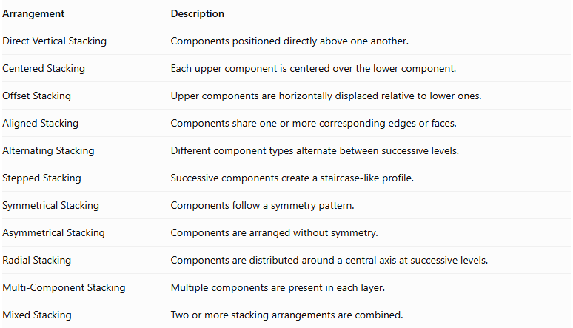
Arrangement | Description
Direct Vertical Stacking | Components positioned directly above one another.
Centered Stacking | Each upper component is centered over the lower component.
Offset Stacking | Upper components are horizontally displaced relative to lower ones.
Aligned Stacking | Components share one or more corresponding edges or faces.
Alternating Stacking | Different component types alternate between successive levels.
Stepped Stacking | Successive components create a staircase-like profile.
Symmetrical Stacking | Components follow a symmetry pattern.
Asymmetrical Stacking | Components are arranged without symmetry.
Radial Stacking | Components are distributed around a central axis at successive levels.
Multi-Component Stacking | Multiple components are present in each layer.
Mixed Stacking | Two or more stacking arrangements are combined.

Classification by Component Types

Same-Shape Stacked Composite Solids
# Source: AI Source: Provided by: [Data Path: Persons Table -> ID Column: 1, Name_En Column: Motasem Essam] -> From: [ChatGPT] on [7/25/2026]
All components belong to the same geometric solid category.
Examples:
- Cube-Based Stacking.
- Rectangular Prism-Based Stacking.
- Cylinder-Based Stacking.
- Cone-Based Stacking.
- Pyramid-Based Stacking.
- Sphere-Based Stacking.
- Hemisphere-Based Stacking.

Mixed-Shape Stacked Composite Solids
# Source: AI Source: Provided by: [Data Path: Persons Table -> ID Column: 1, Name_En Column: Motasem Essam] -> From: [ChatGPT] on [7/25/2026]
Components belong to different geometric solid categories.
Examples:
- Prism-Cylinder Stacking.
- Prism-Cone Stacking.
- Prism-Pyramid Stacking.
- Cylinder-Cone Stacking.
- Cylinder-Sphere Stacking.
- Cylinder-Hemisphere Stacking.
- Cone-Pyramid Stacking.
- Multi-Type Stacking.
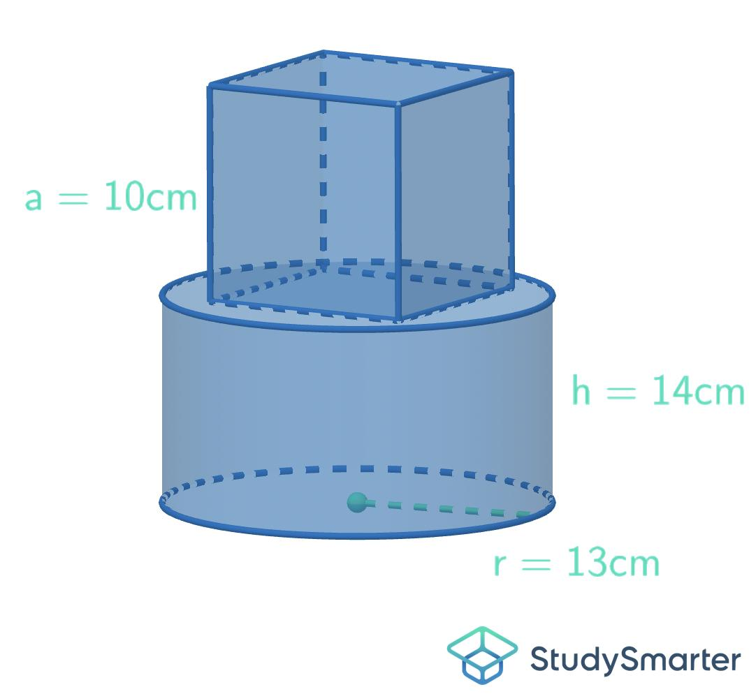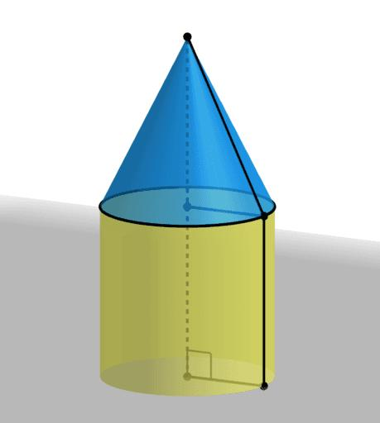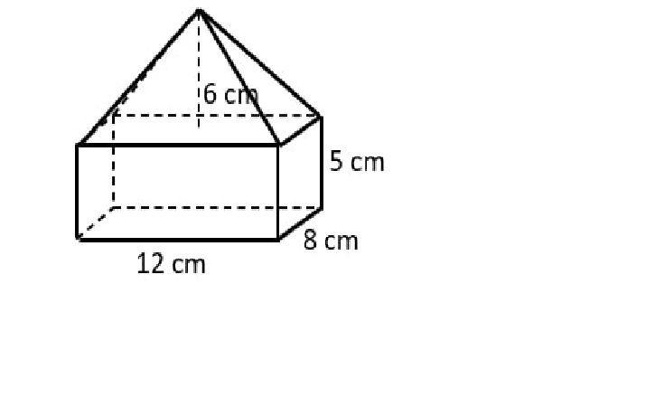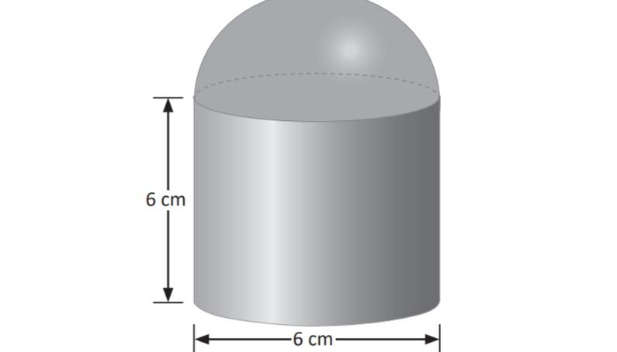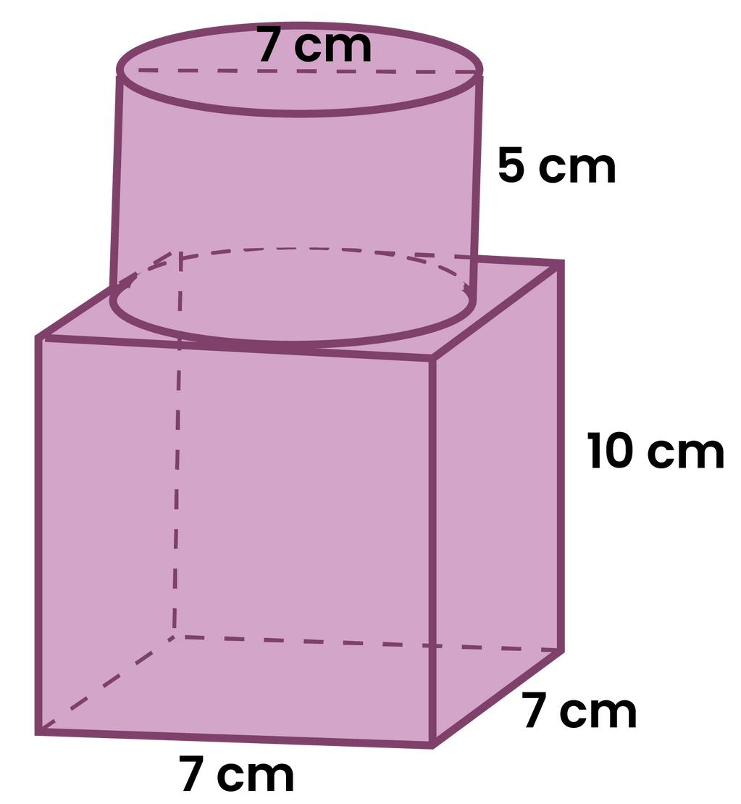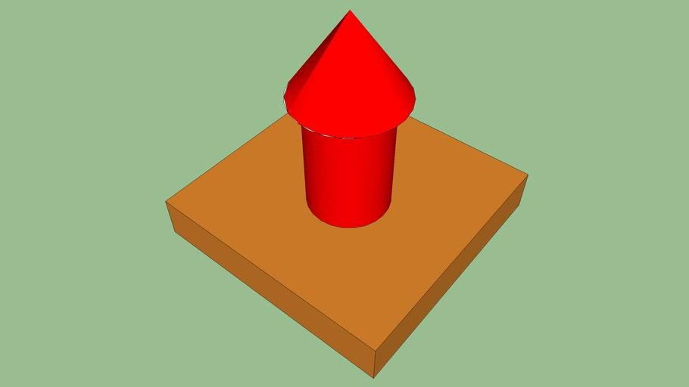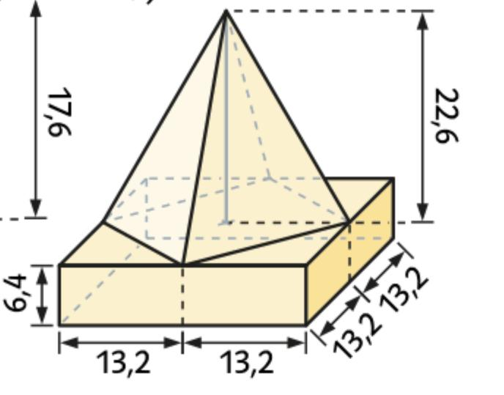

Mathematical Properties and Formulas

Total Volume of Stacked Composite Solids
# Source: AI Source: Provided by: [Data Path: Persons Table -> ID Column: 1, Name_En Column: Motasem Essam] -> From: [ChatGPT] on [7/25/2026]
When the components are stacked without overlapping interiors, the total volume is the sum of their individual volumes.
$$\boxed{V_{total}=\sum_{i=1}^{n}{V_{i}}}$$
For $n$ identical components:
$$\boxed{V_{total}=nV}$$
For multiple layers:
$$V_{total}=V_{1}+V_{2}+⋯+V_{k}$$
Where:
- $V_{i}$ = Volume of a component or layer.
- $n$ = Number of identical components.
- $k$ = Number of layers.
If components overlap internally, the overlapping volume must be subtracted.

Volume Formulas for Common Components
# Source: AI Source: Provided by: [Data Path: Persons Table -> ID Column: 1, Name_En Column: Motasem Essam] -> From: [ChatGPT] on [7/25/2026]
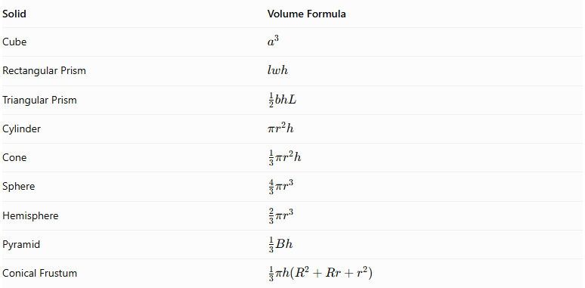
Solid | Volume Formula
Cube | $$a^{3}$$
Rectangular Prism | $$lwh$$
Triangular Prism | $$\frac{1}{2}bhL$$
Cylinder | $$πr^{2}h$$
Cone | $$\frac{1}{3}πr^{2}h$$
Sphere | $$\frac{4}{3}πr^{3}$$
Hemisphere | $$\frac{2}{3}πr^{3}$$
Pyramid | $$\frac{1}{3}Bh$$
Conical Frustum | $$\frac{1}{3}πh(R^{2}+Rr+r^{2})$$

Overall Height
# Source: AI Source: Provided by: [Data Path: Persons Table -> ID Column: 1, Name_En Column: Motasem Essam] -> From: [ChatGPT] on [7/25/2026]
For vertically stacked components that do not overlap:
$$\boxed{H_{total}=h_{1}+h_{2}+⋯+h_{n}}$$
Where $h_{i}$ is the vertical height contributed by each component.
This assumes that the vertical heights are measured along the same direction and that the components are arranged successively.

External Surface Area
# Source: AI Source: Provided by: [Data Path: Persons Table -> ID Column: 1, Name_En Column: Motasem Essam] -> From: [ChatGPT] on [7/25/2026]
The external surface area includes only the surfaces visible from outside the complete stacked structure.
For components joined through complete matching planar faces:
$$\boxed{{SA}_{external}=\sum{{SA}_{i}}-2\sum{A_{contact}}}$$
Where:
- ${SA}_{i}$ = Surface area of each separate component.
- $A_{contact}$ = Area of a complete joining interface.
For partial contact, subtract twice the actual hidden contact area, not the entire face area.
For curved contact or intersecting components, the actual exposed surface regions must be calculated directly.

Surface Area of Common Components
# Source: AI Source: Provided by: [Data Path: Persons Table -> ID Column: 1, Name_En Column: Motasem Essam] -> From: [ChatGPT] on [7/25/2026]
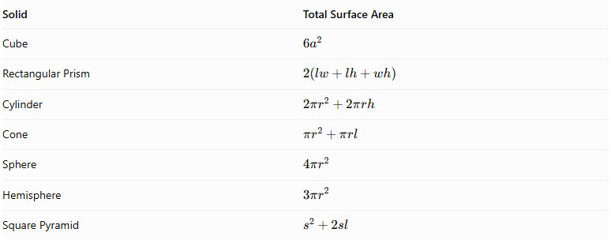
Solid | Total Surface Area
Cube | $$6a^{2}$$
Rectangular Prism | $$2(lw+lh+wh)$$
Cylinder | $$2πr^{2}+2πrh$$
Cone | $$πr^{2}+πrl$$
Sphere | $$4πr^{2}$$
Hemisphere | $$3πr^{2}$$
Square Pyramid | $$s^{2}+2sl$$

Worked Examples

Example 1: Three Rectangular Prisms Stacked Vertically
# Source: AI Source: Provided by: [Data Path: Persons Table -> ID Column: 1, Name_En Column: Motasem Essam] -> From: [ChatGPT] on [7/25/2026]
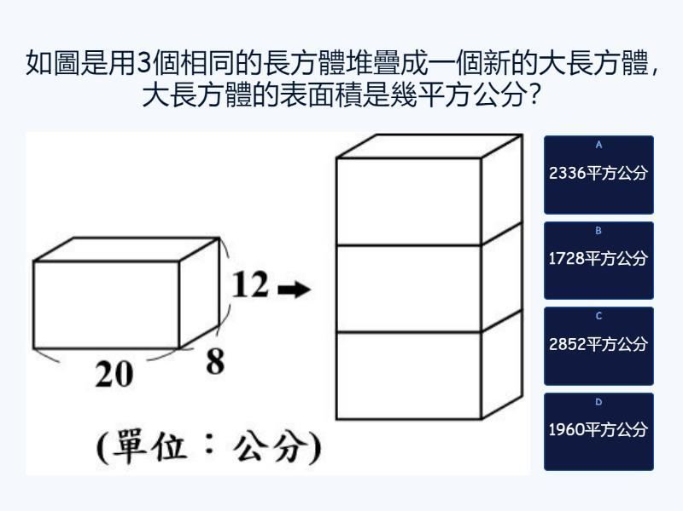
Given:
Three identical rectangular prisms are stacked vertically.
Each prism has:
- Length = $6 cm$
- Width = $4 cm$
- Height = $3 cm$
Step 1: Calculate the volume of one prism.
$$V=lwh$$
$$V=6×4×3$$
$$V=72{ cm}^{3}$$
Step 2: Calculate the total volume.
$$V_{total}=3×72$$
$$\boxed{V_{total}=216{ cm}^{3}}$$
Step 3: Calculate the overall height.
$$H_{total}=3+3+3$$
$$\boxed{H_{total}=9 cm}$$
Step 4: Calculate the external surface area.
The three prisms form one larger rectangular prism with dimensions:
- Length = 6 cm
- Width = 4 cm
- Height = 9 cm
$$SA=2(lw+lh+wh)$$
$$SA=2(6×4+6×9+4×9)$$
$$SA=2(24+54+36)$$
$$\boxed{SA=228{ cm}^{2}}$$
<badge color="success">Final Answer</badge>
- Total Volume = $216{ cm}^{3}$
- Overall Height = $9 cm$
- External Surface Area = $228{ cm}^{2}$

Example 2: A Cylinder Stacked Between a Hemisphere and a Cone
# Source: AI Source: Provided by: [Data Path: Persons Table -> ID Column: 1, Name_En Column: Motasem Essam] -> From: [ChatGPT] on [7/25/2026]
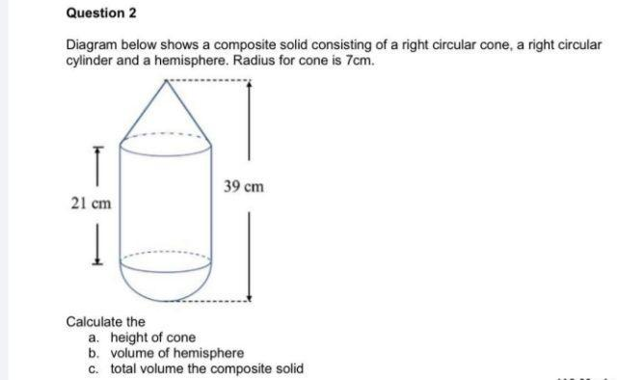
A composite solid consists of:
- A hemisphere at the bottom with radius $3 cm$.
- A cylinder in the middle with radius $3 cm$ and height $6 cm$.
- A cone at the top with radius $3 cm$ and height $4 cm$.
All components are coaxial and joined through their matching circular bases.
Step 1: Calculate the hemisphere volume.
$$V_{1}=\frac{2}{3}πr^{3}$$
$$V_{1}=\frac{2}{3}π(3)^{3}$$
$$V_{1}=18π$$
Step 2: Calculate the cylinder volume.
$$V_{2}=πr^{2}h$$
$$V_{2}=π(3)^{2}(6)$$
$$V_{2}=54π$$
Step 3: Calculate the cone volume.
$$V_{3}=\frac{1}{3}πr^{2}h$$
$$V_{3}=\frac{1}{3}π(3)^{2}(4)$$
$$V_{3}=12π$$
Step 4: Calculate the total volume.
$$V_{total}=18π+54π+12π$$
$$\boxed{V_{total}=84π≈263.89{ cm}^{3}}$$
Step 5: Calculate the overall height.
$$H_{total}=3+6+4$$
$$\boxed{H_{total}=13 cm}$$
Step 6: Calculate the external surface area.
Hemisphere curved surface area:
$${CSA}_{1}=2πr^{2}=18π$$
Cylinder curved surface area:
$${CSA}_{2}=2πrh=36π$$
Cone slant height:
$$l=\sqrt{3^{2}+4^{2}}=5$$
Cone curved surface area:
$${CSA}_{3}=πrl=15π$$
The circular joining bases are hidden inside the structure. Therefore:
$${SA}_{external}=18π+36π+15π$$
$$\boxed{{SA}_{external}=69π≈216.77{ cm}^{2}}$$
<badge color="success">Final Answer</badge>
- Total Volume = $84π≈263.89{ cm}^{3}$
- Overall Height = $13 cm$
- External Surface Area = $69π≈216.77{ cm}^{2}$

Important Characteristics
# Source: AI Source: Provided by: [Data Path: Persons Table -> ID Column: 1, Name_En Column: Motasem Essam] -> From: [ChatGPT] on [7/25/2026]
- Stacked composite solids contain two or more geometric components arranged at different levels.
- Components may be identical or belong to different geometric categories.
- The structure may contain two, three, or multiple layers.
- Components may be centered, aligned, offset, or arranged radially.
- Stacking may produce vertical, stepped, pyramid-like, or irregular structures.
- Each upper component is supported by one or more lower components in a physically supported arrangement.
- The total height depends on the vertical dimensions and relative positions of the components.
- The total volume is calculated by combining the individual component volumes and correcting for overlap.
- External surface area excludes hidden joining surfaces.
- The overall structure may have flat, curved, or mixed surfaces.

Comparison with Other Composite Solids by Component Arrangement
# Source: AI Source: Provided by: [Data Path: Persons Table -> ID Column: 1, Name_En Column: Motasem Essam] -> From: [ChatGPT] on [7/25/2026]
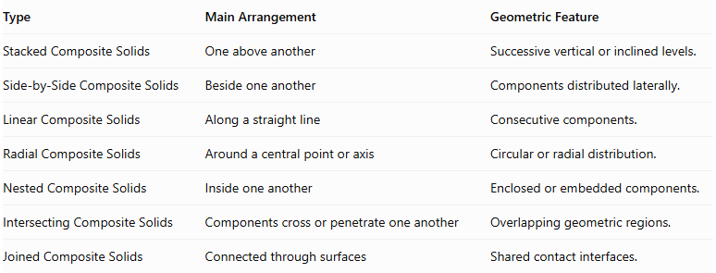
Type | Main Arrangement | Geometric Feature
Stacked Composite Solids | One above another | Successive vertical or inclined levels.
Side-by-Side Composite Solids | Beside one another | Components distributed laterally.
Linear Composite Solids | Along a straight line | Consecutive components.
Radial Composite Solids | Around a central point or axis | Circular or radial distribution.
Nested Composite Solids | Inside one another | Enclosed or embedded components.
Intersecting Composite Solids | Components cross or penetrate one another | Overlapping geometric regions.
Joined Composite Solids | Connected through surfaces | Shared contact interfaces.

Applications
# Source: AI Source: Provided by: [Data Path: Persons Table -> ID Column: 1, Name_En Column: Motasem Essam] -> From: [ChatGPT] on [7/25/2026]
- Architecture: Multi-level buildings, towers, and layered structural designs.
- Construction: Stacked blocks, foundations, and layered building components.
- Mechanical Engineering: Assemblies containing vertically arranged mechanical parts.
- Industrial Design: Products formed from stacked geometric components.
- Manufacturing: Layered and modular manufactured structures.
- Packaging: Containers and products arranged in successive levels.
- Computer Graphics: Modeling towers, stepped structures, and layered objects.
- Mathematics Education: Understanding spatial arrangement, volume, surface area, and three-dimensional composition.

Key Points
# Source: AI Source: Provided by: [Data Path: Persons Table -> ID Column: 1, Name_En Column: Motasem Essam] -> From: [ChatGPT] on [7/25/2026]
- Stacked composite solids consist of two or more components positioned above one another.
- They may contain identical or different geometric solid types.
- Common forms include vertical, layered, uniform, non-uniform, stepped, pyramid-like, and mixed-shape stacking.
- They may contain one, two, three, or multiple layers.
- Total volume is the sum of the individual component volumes when there is no overlap.
- Overall height is the sum of successive vertical component heights when there is no overlap.
- External surface area includes only exposed surfaces.
- Joining interfaces must be excluded from external surface-area calculations.

Conclusion
# Source: AI Source: Provided by: [Data Path: Persons Table -> ID Column: 1, Name_En Column: Motasem Essam] -> From: [ChatGPT] on [7/25/2026]
Stacked Composite Solids are three-dimensional structures formed by arranging geometric components in successive vertical or inclined levels. They can consist of identical solids or combinations of different geometric shapes.
Their configurations include uniform stacking, layered arrangements, stepped structures, pyramid-like formations, symmetrical structures, and mixed-shape assemblies.
Understanding the dimensions, positions, joining surfaces, and component types is essential for determining their total volume, overall height, and external surface area.

